INSERT INTO `teacher`(`TeacherName`, `TeacherPassword`)

VALUES ('Mr Major', 'InverKia5');

INSERT INTO `teacher`(`TeacherName`, `TeacherPassword`)

VALUES ('Mr McDonald', 'BigMAC');

INSERT INTO `teacher`(`TeacherName`, `TeacherPassword`)

VALUES ('Mr Hamilton', 'DankMemes420');

INSERT INTO `teacher`(`TeacherName`, `TeacherPassword`)

VALUES ('Mr McQuilken', 'CalmacFerry1');

INSERT INTO `teacher`(`TeacherName`, `TeacherPassword`)

VALUES ('Mr Bolster', 'CurryPotato');

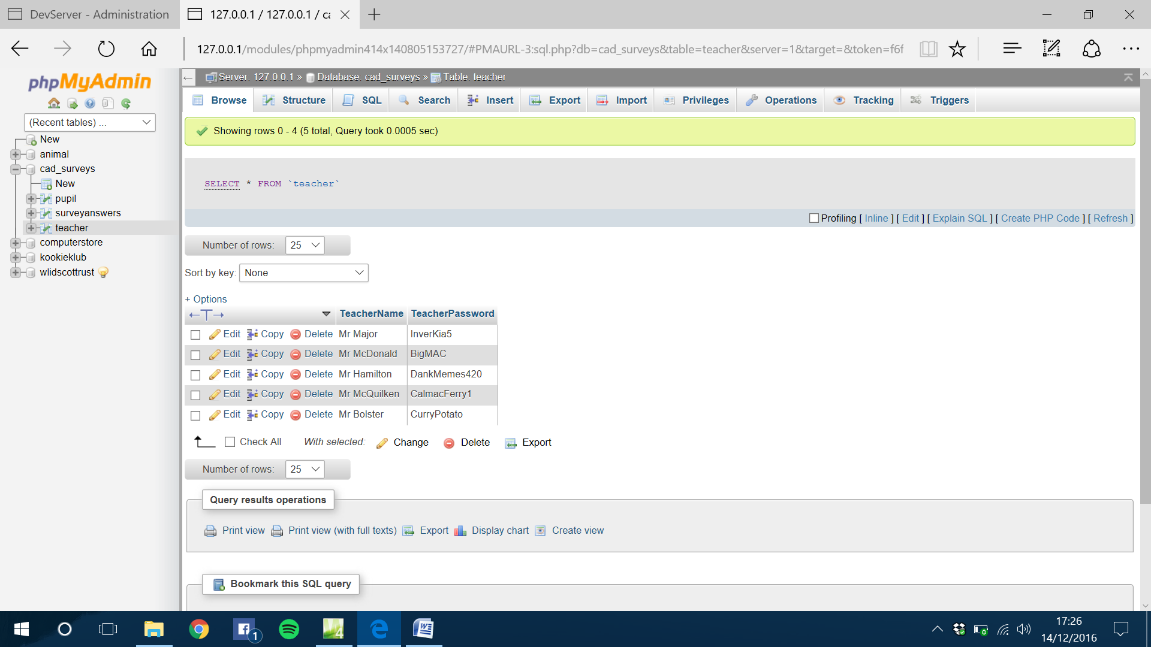

Error!!!

